St. Anne's Arts and Science College
Department of Computer Science

Team Members | Register No | Project Name | Phase Topic
PRIYANKA.G | 222409485 | FitTrack AI - Personalized Fitness  Recommendations  Powered by AI | Phase 5  PROJECT  DEVELOPMENT
PUSHPA BIBIYA.J | 222409486
REVATHY.V | 222409487
RUBA LATHA.M | 222409488

FITTRACK AI
Personalized Fitness Recommendations Powered by AI

PHASE 5
PROJECT DEVELOPMENT PHASE

Project Name: AI FitTrack
Technology Stack: Node.js, Express.js, MongoDB, Mongoose, JWT, bcrypt.js, Google Gemini AI

CONTENTS
Section | Topic
5.1 | Development Overview
5.2 | Backend Server Development
5.3 | Database Implementation
5.4 | User Authentication Development
5.5 | Workout Management Development
5.6 | AI Recommendation Development
5.7 | Fitness Insights Development
5.8 | Authentication Middleware
5.9 | Error Handling and Validation
5.10 | Integration of Project Modules
5.11 | Phase Summary

PHASE 5 – PROJECT DEVELOPMENT PHASE

5.1 Development Overview
The development phase focused on transforming the planned design of AI FitTrack into a functional backend application. Implementation was organized into modules so that authentication, database operations, workout management, AI services, middleware, and error handling could be developed and maintained as distinct parts of the system.
The backend was developed using Node.js and Express.js. MongoDB and Mongoose provide data storage and data-model management, while Google Gemini is integrated to support AI-based fitness recommendations and insights.

5.2 Backend Server Development
The backend server was developed using Express.js. It receives client requests, directs them through the appropriate routes and middleware, and returns responses in JSON format.
The server implementation includes environment-variable configuration, JSON request parsing, CORS configuration, API route registration, and centralized error handling. These elements provide the foundation for processing requests across the application.

5.3 Database Implementation
MongoDB was implemented as the primary database for storing user and workout information. Mongoose is used to define schemas and manage communication between the Node.js application and MongoDB.
The database implementation is organized around two main data models:
- User Model: stores user details, including name, email, password, and timestamps.
- Workout Model: stores workout name, category, duration, calories burned, workout date, and a reference to the associated user.
The models provide a structured representation of the data managed by the backend.

5.4 User Authentication Development
The authentication module was developed to control access to the application and its protected resources.
During registration, the API accepts the required user details and stores the password in protected form using bcrypt.js. During login, the submitted credentials are verified, and a JSON Web Token (JWT) is generated for authenticated access.
For protected API requests, the client sends the JWT in the Authorization header. Authentication middleware verifies the token before allowing the request to proceed to the protected operation.
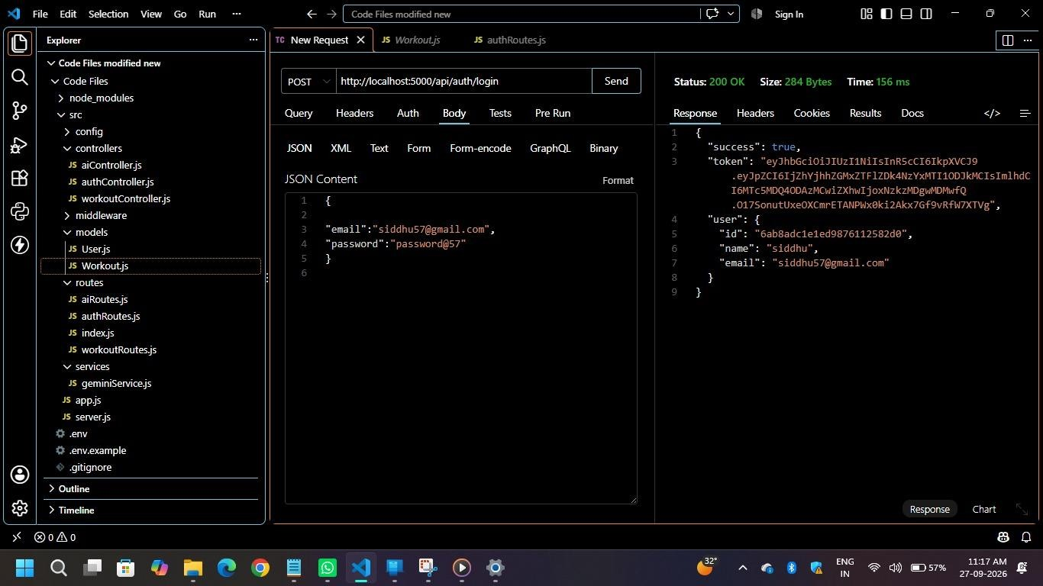

5.5 Workout Management Development
The workout management module was developed to allow authenticated users to maintain their workout records. The module supports the following operations:
- Adding a new workout record.
- Viewing workout records.
- Retrieving an individual workout by its ID.
- Updating an existing workout record.
- Deleting a workout record.
- Searching workouts by name, category, or date.
The Workout model applies validation to important fields, including workout category, duration, and burning calories. These validations help maintain consistency in the workout data submitted to the API.
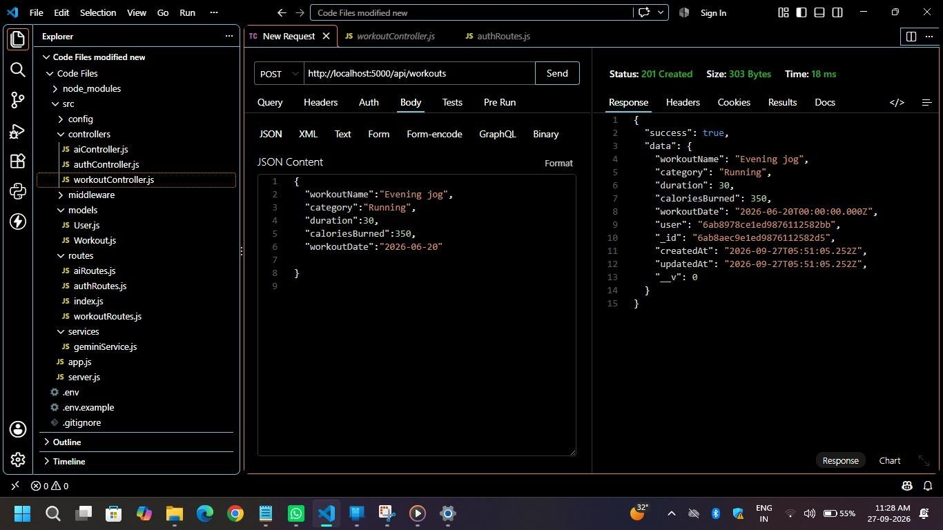

5.6 AI Recommendation Development
The AI recommendation module was developed by integrating Google Gemini with the backend application. The service uses information supplied by the user, such as age, fitness goal, and experience level, to generate personalized fitness guidance.
The generated response may include workout plans, weekly exercise suggestions, recommendations suited to the user’s experience level, motivational guidance, and safety tips.
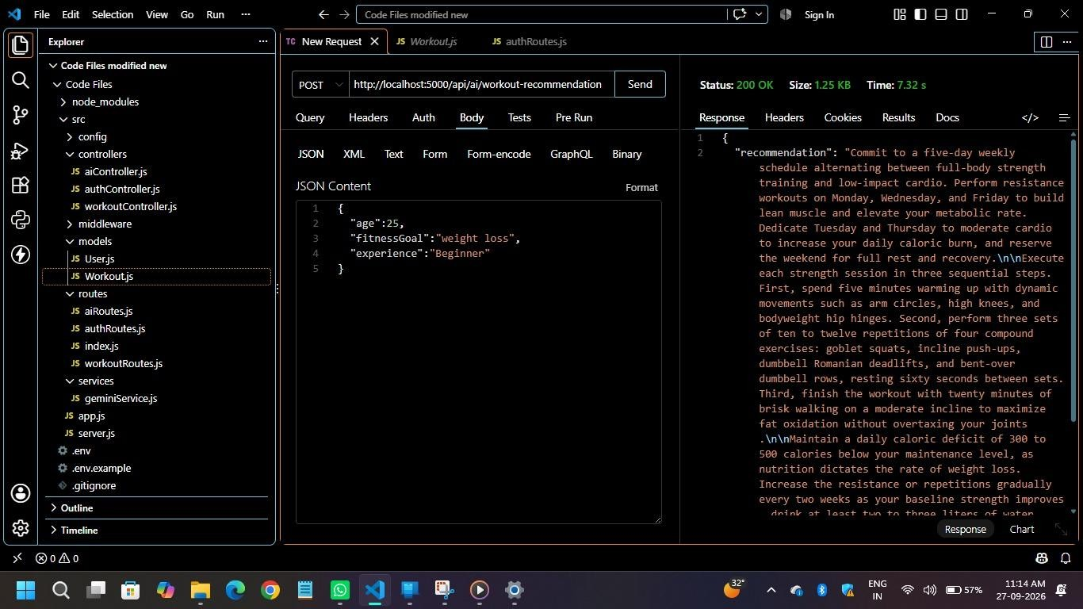

5.7 Fitness Insights Development
Along with personalized recommendations, AI FitTrack includes an AI-based fitness insights feature. This service uses workout statistics to generate fitness-related insights for the user.
The statistics used by the feature include:
- Total number of workouts.
- Average workout duration.
- Total calories burned.
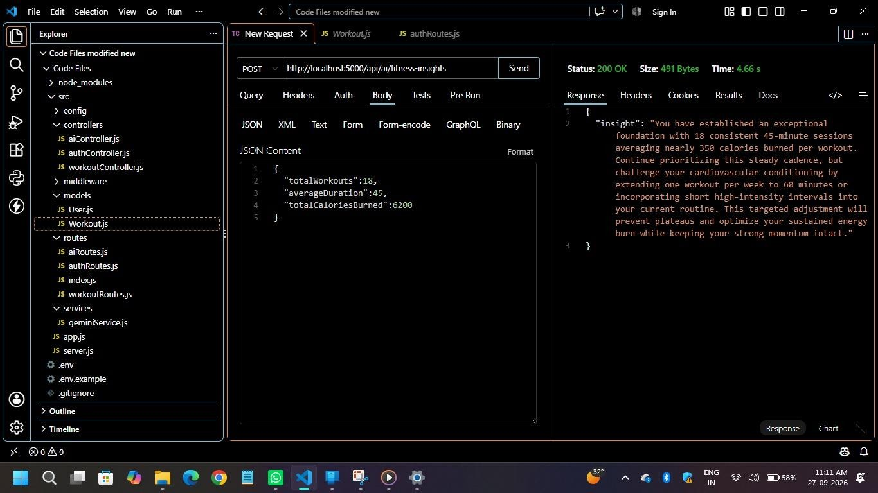

5.8 Authentication Middleware
Authentication middleware was implemented to protect API endpoints that require a logged-in user. When a protected request is received, the middleware reads the JWT from the Authorization header and verifies its validity.
If the token is valid, the authenticated user’s information is made available to the request so that the relevant operation can continue. If authentication is not valid, the request is rejected before it reaches the protected controller.

5.9 Error Handling and Validation
Validation and error handling were incorporated into the backend to support reliable API operations. Input validation is applied through the defined Mongoose schemas, while centralized error handling provides a consistent mechanism for managing application errors.
The API uses a standardized JSON response structure to communicate results and errors to its clients.

5.10 Integration of Project Modules
After the individual modules were developed, they were integrated to form the complete backend system. The integrated request flow connects the client, Express server, API routes, authentication middleware, controllers, services or models, and the relevant external or database resources.
Client → Express Server → Routes → Authentication Middleware\n→ Controllers → Services / Models
→ MongoDB or Gemini AI\n→ JSON Response

5.11 Phase Summary
The development phase brought together the main backend capabilities of AI FitTrack. The Express server provides the API entry point, Mongoose models support user and workout data management, and JWT with bcrypt.js supports authentication. Workout management operations and Google Gemini-based recommendations and insights are integrated within the backend, with middleware and error handling supporting request processing. The resulting implementation forms the basis for the subsequent testing phase.

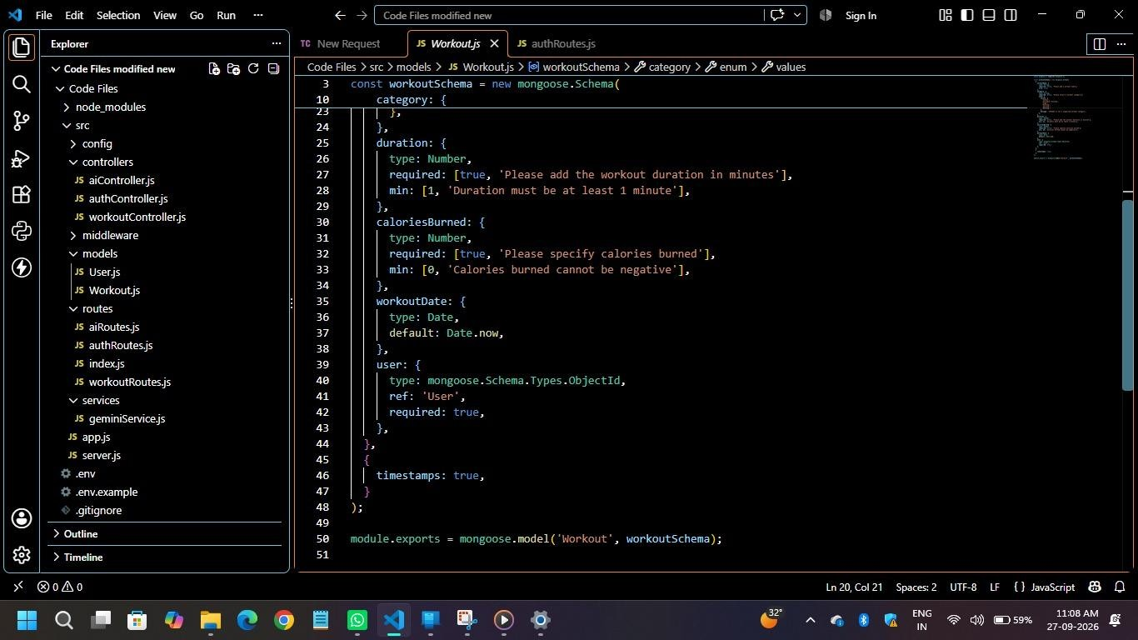
Figure 5.1: Development - Create Workout

Figure 5.2: Development - GET Workouts

